|  |  |
| --- | --- |
| Image result for little smarties jeddah | Converter |

**Executive Summary**

The service we are about to discuss is the learning experience at a kindergarten and early years elementary school. In this short paper, we will focus on the decentralization between different department in the school and the duplication of work due to lack of IT systems integration. This comprehensive application of CSVLOD model is an essential step to discuss the enhancement expected on the organization’s activities with decision makers and colleagues.

**The Problem**

The company was established 12 years ago as a daycare center and developed its services throughout the years to satisfy the increasing market demand. Our plan is to expand by opening new higher elementary classes as our customers (kids) are growing with us. Currently we are operating at two educational buildings.

The problem we are about to discuss in order to suggest solutions by aligning business and IT objectives relates to how different departments at the company can apply IT solutions that can help in centralizing the work and achieve solutions’ integration to improve performance and reduce effort and cost.

1. **Enterprise Overview**

**A.1 Vision**

To be an institution recognized with exceptional services offering efficient and reliable educational childcare services at an affordable cost.

**A.2 Strategies**

The company follows **cost leadership** strategy, the schools offer quality services at competitive educational fees. Therefore, reducing expenses is one of the company’s priorities in order to achieve profit.

The schools’ strategic plan is to expand by offering higher elementary classes every year. Although our main services focus is kindergarten, however, the purpose is to support updating the current business plan to sustain quality on the existing services and assist in the decision of developing new services for higher grades and most importantly reduce financial waist.

**A.3 IT Department History**

The company started 12 years ago as a startup with no IT infrastructure or investment. Microsoft office was used for scheduling, registration and teaching purposes. After 5 years, accounting solution has been used for bookkeeping and auditing. Moreover, a static web site has been established. Three years ago, a registration system has been applied to facilitate the registration process and school dashboard and parents’ communication.

Covid-19 pandemic has forced the company to apply e-learning solutions offered by the government like Madrasaty platform and Zoom application for our accredited international curriculum.

**A.4 Systems Environments**

1. Accounting System
2. E-learning System and Parent Portal
3. Registration System
4. **Scope of the Organization**

**B.1 The scope of the organization's works and who are the expected well gain from the artefact the facility's functioning?**

The company that we are going to relate to in this paper is offering a daycare service, kindergarten and early elementary years school. Our services include:

1. Daycare from 3 month to 3 years.
2. Kindergarten from age 3 to 6
3. Early elementary for grade 1 and 2.

The expected well gain will include many business and IT aspects of the organization. This may include service quality, HR performance, parents’ communication and financial performance of the company. All these aspects should be considered in the journey of digital transformation as they will have a direct impact on the enterprise performance.

**B.2** **CSVLOD Model Application**

Applying CSVLOD model will improve the performance of the company

by using more efficient integrated solutions that will reduce work redundancy between departments and reduce financial waste accordingly.

The model helps simplify the relationship between business rules, architecture and changes to the IT ones so the communication between the two workgroups will be more realistic and structured.

Generally, businesspeople don’t see the benefit of investing in such model applications and IT solutions, however, this model will help us introduce how these applications can be reflected positively on the financial performance of the enterprises.

The model will help to identify organizing what we have already and will highlight the areas that need work to be aligned and connected to the business strategy.

**B.3 Potential of eight main artifact and the roadmap**

1. **Consideration**

Considerations are the business focused global rules that is important to the business and relevant to IT. These rules help to achieve business values and objectives. Considerations can be more identified by principles and polices. Example of the considerations in our enterprise is **to standardize business processes, as this is important to align activities at all business departments.**

**1.1 Principles**

**Principle 1**

**Statement**

Maintain good level of internal interactions and communication

**Rationale**

Commitment of engagement and advocacy

**Implication**

Transparency that will lead to improving our services.

**--------------------------------------------------------------------------------------**

**Principle 2**

**Statement**

Our people are our greatest asset

**Rationale**

Always maintain employees’ dedication and determination

**Implication**

It is only with our people that we can serve our clients and generate long term value

**--------------------------------------------------------------------------------------**

**Principle 3**

**Statement**

Understanding our clients by improving communication

**Rationale**

Clients come first, continuous assessments and collecting feedback about our services to assure quality and safety

**Implication**

Help understand clients’ need and improve our services

1. **Standards**

Standards are the global technical focused rules that includes best practices relevant to IT. At this section applications and integration between the are stated and the models used as a reference for technology. Guidelines of several aspects of technical components are described in detail in this section.

**2.1 Technology Reference Model (TRM)**

|  |  |  |  |  |  |
| --- | --- | --- | --- | --- | --- |
| **Delivery** | | | **Channel** | | |
| **Office 365** | **Network** | | **Zoom** | | **Web Application** |
| **Laptop, desktop** | **Mobile** | | **Mdrasaty** | | **Teams** |
| **Noor** | **Email** | | **Smart thatching system** | | **WhatsApp** |
| **Application And Integration** | | | | | |
| **Microsoft office** | **Madac** | | **Chrome** | | **Financial analysis system** |
| **Database and information management** | | | | | |
| **SQL** | **Oracle** | | **Mangodb** | | |
| **Security and access management** | | | | | |
| **Authentication** | **Encryption** | | **Privacy policy** | | **Group membership admin** |
| **Infrastructure and network** | | | | | |
| **Network Connectivity** | **Safety and security System** | | **Server** | | |
| **Unsupported** | | **Current** | | **Emerging** | |

**2.2 Guidelines**

|  |  |
| --- | --- |
| **Server deployment** | **Guideline 1:** Applications should be run as OS services  **Description:** The rationale behind this guideline is to ensure that applications continue running independently of the user and session. In other words, the application runs before a user log-in and continues to run after log-off to minimize disruptions. |
| **Guideline 2:** Deployment packages should be stored in VCS  **Description:** Software configuration management is imperative, and the utilization of VCS helps to track changes to an application by each contributor and prevents conflicts associated with concurrent work. |
| **Network protocol** | **Guideline 3:** UDP multicast should be avoided.  **Description:** UDP multicast is associated with increased communication latency, slow error correction, incompatibility with packet broadcast, and the possibility of packets arriving in an unordered manner. |
| **Guideline 4:** REST should be utilized over SOAP.  **Description:** REST is better as it exhibits simplicity and supports diverse data formats. It is also faster and utilizes less bandwidth. |
| **Data encryption** | **Guideline 5:** 128-bit encryption keys should be utilized to encrypt data.  **Description:** 128-bit keys provide adequate security levels. The organization should use the advanced encryption standard (AES) as it is a 128-bit symmetric block cipher. |
| **Guideline 6:** Passwords should be stored as MD5 hashes.  **Description:** Hashing passwords reduces the risk of them being hacked. |
| **Interface design** | **Guideline 7:** Web-safe colors should be utilized.  **Description:** Colors utilized should support the utilization of the web application rather than distract the user. |
| **Guideline 8**. The menu should be placed in the top right corner.  **Description:** This placement of the menu enhances the usability of the application. |
| **Secure coding** | **Guideline 9:** Variables should be initialized to safe defaults.  **Description:** Initialization prevents a situation where unpredictable outputs are experienced when the program is executed. |
| **Guideline 10**: Incoming data should be validated.  **Description**: Data validation prevents security issues, including SQL injection attacks. |

1. **Vision**

The vision introduces the business focused structure to help achieve business objectives by aligning between IT solutions and business strategies and outcomes. The enterprise strategy for instance indicates that our services have to be at affordable prices this should be considered to attain business alignment with the decisions of IT investments.

* 1. **Business Capability Model**

**Business Strategy**

**Provide the best educational experience at affordable fees (Cost leadership strategy)**

|  |  |  |
| --- | --- | --- |
| **Goal 1** | **Goal 2** | **Goal3** |
| Increase Customer Satisfaction | Maintain best educational services | Improve financial performance |

Capability 1: Solid Parents-School

Capability 2: Experienced Teachers and High Standards Curriculums

Relationship

1.3 Systematic follow up activities

1.1 Parents Loyalty building programs

1.2 Parents continuous follow up

1.4 Parents’ satisfaction measured and controlled

1.3 International Accreditation

1.2 Well educated Supervisors

1.1 Teachers’ level of experience

1.4 Hands on Activities and programs

Capability 4: Service Integration and Competencies

1.4 Safety requirements

1.3 Supervision System

1.2 Complains tracking

1.1 Front line customer service

Capability 3: Financial Performance Optimization

1.1 Book keeping activities

1.2 Managing expenses

1.3 Improve asset utilization

1.4 Budgeting and target projection

Strategic

Important

Regular

* 1. **Roadmaps**

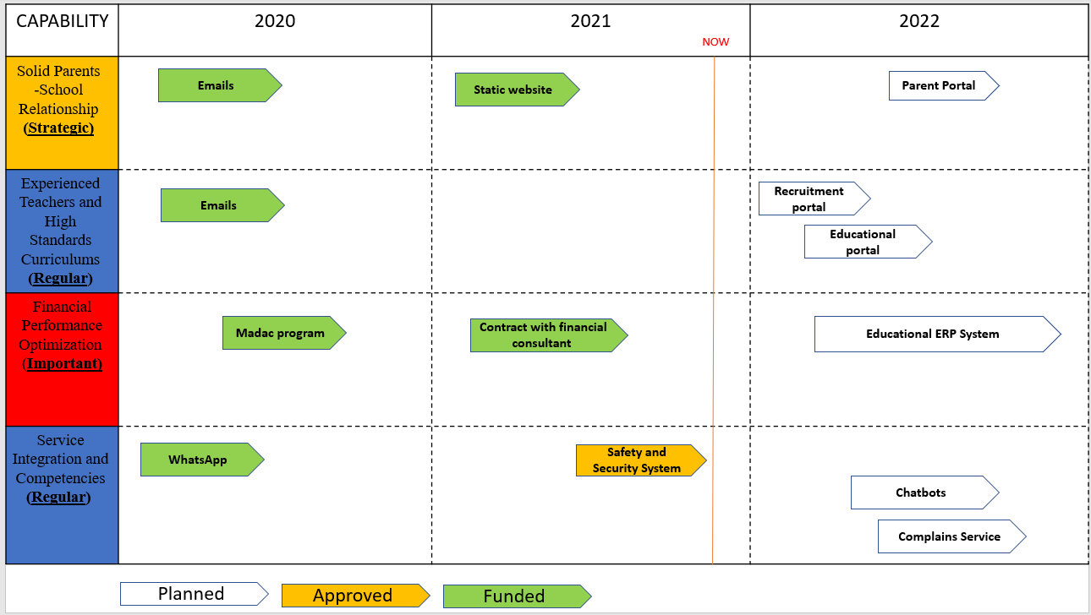

1. **Landscapes**

Landscapes support understanding and analyzing IT structure to assess IT project planning. Landscapes Diagram gives a detailed rationalized structure of IT plans

* 1. **Landscapes Diagrams**

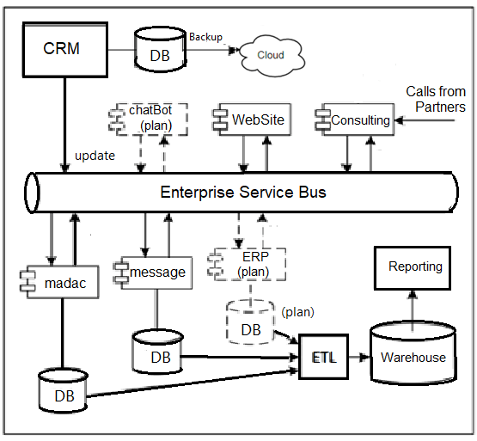

1. **Outlines**

In this artifact, business focused benefits are stated in order to improve efficiency and achieve targeted RIO of IT investments.

The most important principle at the school from business overview is to Maintain good level of internal interactions and communication as we have already discussed in the consideration section.

To elaborate more in this area and to highlight how transparency and good level of communication can be achieved and have a direct positive impact on ROI, Solution Overview will be focused on the suggested solutions to improve School-Parents relationship.

We suggest to discuss the recommended solution of **Web Application as a Parents’ Portal**

* 1. **Solution Overviews**

**Overview and Goals**

* The platform will target parents in order to facilitate the communication process with the school and handle day to day updates.
* The platform will digitalize daily tasks and operations.
* Achieving this goal will allow the company to serve a larger segment of our target customer increase loyalty and business returns accordingly.

**Scope**

|  |  |  |
| --- | --- | --- |
| SCOPE | DESCRIPTION |  |
| 1. Market Research Report | A detailed report identifying customer personas and full market research outcomes | |
| 1. Customer Journey | Identifying the steps that the customers go through during the journey of the portal | |
| 1. Software Requirement Specification | A document that describes what the software will do and how it will be performing | |
| 1. Web Design | Creation of a creative interface design of the website and branding | |
| 1. Web Application | An application of the online representation, ecommerce and multimedia of the service | |
| 1. Testing Modification Report | Planning, controlling and monitoring throughout the whole project | |

**Essential Requirements**

1. Quality of Market Research
2. Quality of interface design
3. Functionality of the website
4. Quality of training outcomes
5. Quality of testing outcome
6. Safety and application security
7. Reliable internet connection.

**Business Benefits**

1. Increase asset utilization.
2. Cut expenses.
3. Increase return of investment.
4. Support long term expansion.
5. Decrease manpower expenses.
6. Service optimization.

**Capability Impact**

* Digitalizing communication will increase loyalty and trust, this will directly impact the level of services provided by the school and enhance productivity and efficiency.
* Service can be measured and improved accordingly.
* Packages personalization opportunity.

**Involved Partners**

* Web Developer
* Data Analysist for market research
* Current employees doing relevant tasks.
* Business leaders
* In-school IT specialists.

**Estimations**

**Time**

Three Month (Testing included)

**Cost**

Project total budget is ------------------------- 50 K

* Product Development ----------------- 20%
* Training ------------------------------------ 15%
* Website Development ------------------ 50%

Testing ------------------------------------- 15%

**Business Process Change**

**Time consuming current process**



Emails

Phone Calls

Current School

Parents

WhatsApp

**Real time tasks and processes**



Market



Better Access to market

Web Application

Centralized Service and Solutions

Parents

Ministry of Education

Regulation

**Architectural Overview**



Landing Page

Parents

E-Learning Integration

Existing Parent

New Parent

Static Input and School Tour

Outstanding Payements

Chatbots

Child Portal

Registration

**Key Risks**

1. High turnover of Saudi competences.
2. Pandemic (Covid19) and online education.
3. Kids Emergency Cases.
4. Variation of staff training outcomes.
5. Safety and security issues
6. Platform Availability
7. **Designs**

Help improving quality of the developed IT project. Business architecture requirements are essential in order to achieve compatibility between architects and project team.

* 1. **Solution Designs**

**B.4 Enterprise Stakeholders**

1. Partners: Owners who invested their money in the company.
2. Board Members: are responsible to guide the company by adopting financial, legal and ethical management policies, also they make sure that the company is achieving its mission.
3. IT Specialists (outsourced): Outsourced companies who are responsible of developing IT solutions.
4. Supervisors: people who are fully aware of the educational rules and polices of the schools. Their role is to assess the education process and conforming to the ministry requirements.
5. Head of department: managers of departments who are leading the processes related to their departments, such as registration, accounting and operations.